**UX feedback**

report

Fontys University of Applied Science Software

Project Plan Individual project:

Tutor: Tim Kurvers & Maja pesic

Student: Mohammed Al Harbi

4089553

Contents

Introduction 3

Peer review 3

Expert feedback 6

DOT framework methods used: 6

# Introduction

After I integrated authentication and authorization in Henaknowledge platform. I wanted to improve the platform in terms of UX to make it even more professional. Thus, in this document I will be showing the feedback I received and some of proofs that I changed the UX based on them.

# Peer review

I demonstrated the Henaknowledge platform to 2 of my peers Kirill smirv and Redo haryono.

* Here is the feedback I received from Kirill:

1) No confirmation when firing a teacher

2) The info under the title is grey and blends in with the background colour

3) Having the code easily visible is a security hazard

4) When you log in the page is empty, maybe go straight to profile

5) Add more input validation like minimum characters required

6) Add a search bar to look for teacher names

7) The sign up page for teacher and student, the word "platform" isn't animated like in many other places

* Here is the feedback I received from Redo:

- if the app only work if the user’s logged in, then why need to hide the login form?

- why logout on the top left?

- I think if the teacher’s specialization comes from a table, the text field in the form should be a dropdown

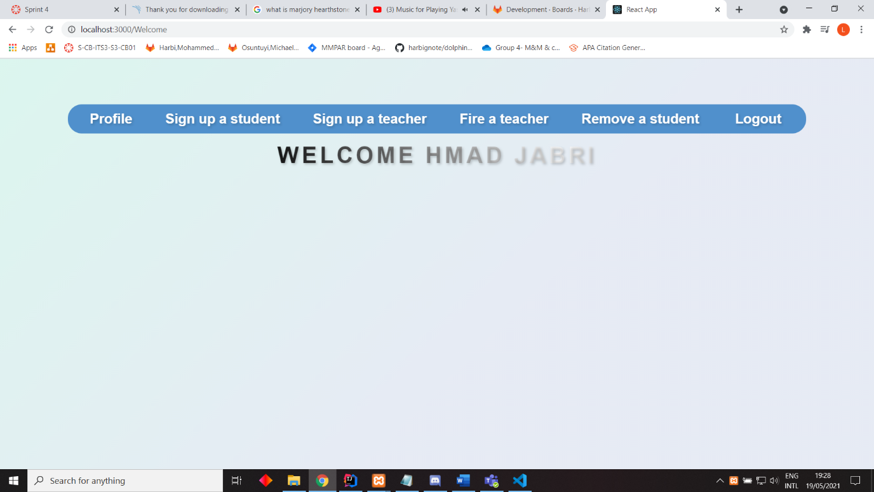

You can notice that the logout on the navigation bar is now moved to the right (It was at the left top when I demoed the platform to the users.)

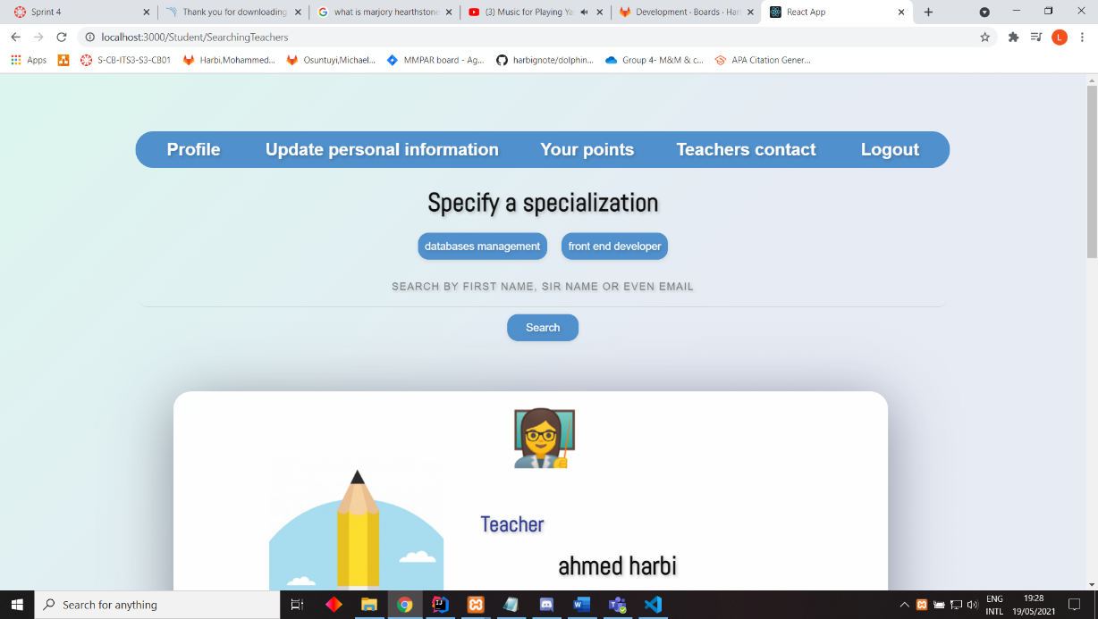

Here I implemented a search bar functionality after I received the feedback from Kirill.

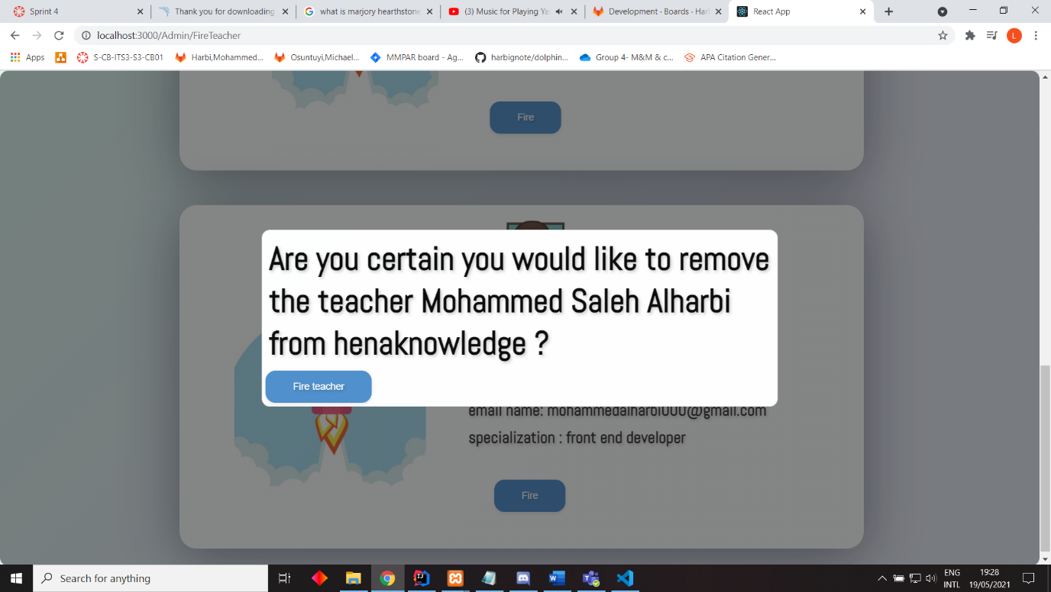

Here I also added a warning message before the administrator fires a teacher.

# Expert feedback

I started admiring receiving feedback from others because it was actually very useful for me. Thus, I contact Roopali Gupta. I asked her for a meeting to give me feedback on the platform and here is the feedback I received after the demo.

1- Landing page can be profile for now

2- align either everything in login in the centre or all left

3- text under Henaknowledge platform should be in one line to make it consistent with the title

4- by default the list of teachers or students should follow an order for example an alphabetical order so that users  
can eventually find who they look for

5- fire, banned are strong organizational words, use more positive ones. remove, access has been removed.

6- code should be generated only after clicking on a redeem points point for instance.

7- check whether a teacher can have multiple specializations and accordingly to it choose if when creating a teacher to use multiple   
checkboxes or a dropdown to specify the specialization(s)

8- have a sort option to allow the student to sort teachers in particular order

9- font of search should be a little bigger so that the student can see what they searched for properly

10- improve the structure of the auto generated email, for example to have this is an autogenerated email please do not reply , ..etc.

11- change the words used in banning the user from Ban to something like your access have been removed if you think

it was a mistake please contact blabla@Gmail.com , ..etc.

# DOT framework methods used:

* [Peer review](https://ictresearchmethods.nl/Peer_review)